Test Report

Project Name: Pinterest

Document Date: 19.11.2020

Tester : Carla Hotico

Table of Contents

A. Testing Scope 3

1.1. Test Environment 3

1.2. Test Specification 5

1.3. Manual Test Cases 6

1.4. Automated Testing 9

1.5. API Testing 9

B. Test Results 10

2.1 Executed Manual Test Cases 10

2.2. Automated Testing - Cypress 11

2.3. API Testing 11

2.4. Lighthouse report 12

C. Bugs and Improvements 12

3.1. Bugs and Defects 12

3.2. Improvements 13

D. Conclusions 14

# A. Testing Scope

App description

[Pinterest](https://www.lifewire.com/pinterest-4102610) is a social site where you can collect and share images of anything you find interesting. You can also visually discover new interests by browsing the collections of other [Pinterest users](https://www.lifewire.com/most-popular-pinterest-users-to-follow-3485976).

Pinterest consists mainly of "pins" and "boards". A pin is an image that has been linked from a website or uploaded. Users can follow and unfollow other users as well as boards, which would fill the "home feed".

Why this application?

The reason why I chose to test this application is because I’ve been using it since I was young, and I’ve been a fan of it ever since. So I was curious if, as someone who really enjoys it, I could think of some improvements, or even to see if, with the knowledge that I now have, I could find some bugs in the app.

What was tested?

During this project, I chose to test the following functionalities: login, search, post, save, messaging, notifications, boards, pins.

## Test Environment

Link to all environments:

- GitHub – The main purpose of GitHub.com is to facilitate the version control and issue tracking aspects of software development. Labels, milestones, responsibility assignment, and a search engine are available for issue tracking. For version control, Git (and by extension GitHub.com) allows pull requests to propose changes to the source code. (https://github.com/CarlaHotico/testaresoftware.git)

- Cypress - Cypress is a JavaScript test automation solution for web applications. It enables teams to create web test automation scripts. This solution aims to enable frontend developers and test automation engineers to write web tests in the de-facto web language that is JavaScript. (https://www.cypress.io/)

- Postman - Postman is a popular API client that makes it easy for developers to create, share, test and document APIs. This is done by allowing users to create and save simple and complex HTTP/s requests, as well as read their responses. The result - more efficient and less tedious work. (https://www.postman.com/)

- TestLink - Test-link is most widely used web based open source test management tool. It synchronizes both requirements specification and test specification together. User can create test project and document test cases using this tool. (https://testlink.scoalainformala.ro/login.php)

- Chrome Dev Tools - Chrome DevTools is a set of web developer tools built directly into the Google Chrome browser. DevTools can help you edit pages

on-the-fly and diagnose problems quickly, which ultimately helps you build better websites, faster.

- Lighthouse - Lighthouse is an [open-source](https://github.com/GoogleChrome/lighthouse), automated tool for improving the quality of web pages. You can run it against any web page, public or requiring authentication. It has audits for performance, accessibility,

progressive web apps, SEO and more. You can run Lighthouse in Chrome DevTools, from the command line, or as a Node module.

For UI tests I used Cypress framework using JavaScript code.

For API test and performance I used the Postman tool.

| Test Environment | Software Details | Comments |
| --- | --- | --- |
|  | Browsers: Chrome, Edge, Explorer  Moblile: Chrome, Internet Samsung |  |
| Production | OS: Windows 10.0.19041.572, Android 10 |  |
|  | Devices: Laptop, Mobile | DevTool app for mobile  - Mobile app + mobile Web |

1.2. Test Specification

Equivalence partition and boundary values applied for specified functionalities:

|  |  |  |  |
| --- | --- | --- | --- |
| Functionality | Boundary | Equivalence part |  |
| Search bar | 0,1,∞ | C1:0 – not valid  C2:1-∞ - valid | Cannot search without any character  Any char number between 1 and ∞ allowed |
| Username | 0,1,∞ | C1:0 – not valid  C2:1-∞ - valid | Field cannot be empty  Any char number between 1 and ∞ allowed |
| Password | 0,1,∞ | C1:0 – not valid  C2:1-∞ - valid | Field cannot be empty  Any char number between 1 and ∞ allowed |

Mind Maps

Links to both Mind Maps:

Initial web app Mind Map: <https://github.com/CarlaHotico/testaresoftware/blob/master/Pinterest%20-%20initial%20mindmap.xmind>

Test specification Mind Map: <https://github.com/CarlaHotico/testaresoftware/blob/master/Pinterest%20test%20specification.xmind>

|  |  |
| --- | --- |
| 1.3. Test Case ID for manual tests | Description |
| TM-QA08-356 | Create account |
| TM-QA08-516 | Create another account with the same email |
| TM-QA08-382 | Edit profile |
| TM-QA08-272 | Login valid username+password |
| TM-QA08-343 | Login valid username+ invalid password |
| TM-QA08-344 | Login invalid username+ valid password |
| TM-QA08-345 | Login invalid username+ invalid password |
| TM-QA08-509 | Login with no input |
| TM-QA08-279 | Save picture |
| TM-QA08-286 | Download photo |
| TM-QA08-287 | Create board |
| TM-QA08-377 | Edit board |
| TM-QA08-351 | Follow new account |
| TM-QA08-371 | Write message |
| TM-QA08-552 | Show notifications for new messages |
| TM-QA08-373 | Show notifications while in mobile app |
| TM-QA08-391 | Show notifications on the website |
| TM-QA08-374 | Receive notifications by email |
| TM-QA08-378 | Receive push notifications |
| TM-QA08-370 | Autocomplete forms |
| TM-QA08-379 | Field validation |
| TM-QA08-381 | Optional and mandatory fields |
| TM-QA08-365 | Search bar-valid |
| TM-QA08-367 | Search-random string of characters |
| TM-QA08-393 | Search bar-empty |
| TM-QA08-395 | Min number of characters |
| TM-QA08-397 | Search bar with numbers |
| TM-QA08-420 | Suggestions |
| TM-QA08-611 | Misspelled word recognition |
| TM-QA08-376 | Share board |
| TM-QA08-549 | Share pin |
| TM-QA08-392 | Upload new picture- web application |
| TM-QA08-553 | Upload new picture- mobile application |
| TM-QA08-291 | Delete board |
| TM-QA08-277 | Logout |
| TM-QA08-551 | End-to-end test : Log in -> Log out |
| TM-QA08-282 | Responsive design test |
| TM-QA08-511 | Mobile browser-Chrome |
| TM-QA08-512 | Mobile browser-Internet Samsung |
| TM-QA08-515 | Mobile application |
| TM-QA08-348 | Browser-Explorer |
| TM-QA08-346 | Browser-Chrome |
| TM-QA08-347 | Browser-Edge |
| TM-QA08-357 | Email account validation |
| TM-QA08-510 | Password is hidden |
| TM-QA08-612 | Fake email address |
| TM-QA08-385 | Response time - Postman |
| TM-QA08-384 | Lighthouse report |

1.4. Automated tests Cypress

From the 49 total manual tests, I have automated 16 tests (about 30%), focusing on these functionalities:

-Log in

-Search

-Board

-End to end

1.5. API Tests

API testing is a type of [software testing](https://en.wikipedia.org/wiki/Software_testing) that involves testing [application programming interfaces](https://en.wikipedia.org/wiki/Application_programming_interface) (APIs) directly and as part of [integration testing](https://en.wikipedia.org/wiki/Integration_testing) to determine if they meet expectations for functionality, reliability, performance, and security. API testing is used to determine whether APIs return the correct response (in the expected format) for a broad range of feasible requests, react properly to [edge cases](https://en.wikipedia.org/wiki/Edge_cases) such as failures and unexpected/extreme inputs, deliver responses in an [acceptable amount of time](https://en.wikipedia.org/wiki/Service-level_agreement), and respond securely to potential [security attacks](https://en.wikipedia.org/wiki/Cyberwarfare).

Smoke tests:

Smoke testing is preliminary testing to reveal simple failures severe enough to, for example, reject a prospective software release. Smoke tests are a subset of [test cases](https://en.wikipedia.org/wiki/Test_case) that cover the most important functionality of a component or system, used to aid assessment of whether main functions of the software appear to work correctly.

End to end tests:

End-to-end testing is a Software testing methodology to test an application flow from start to end. The purpose of End to end testing is to simulate the real user scenario and validate the system under test and its components for integration and data integrity.

# B. Test Results

## 2.1. Executed Manual Test Cases

| Functionality | Total | Pass | Failed | Blocked | Not Run | Defects |
| --- | --- | --- | --- | --- | --- | --- |
| Account | 3 | 3 | 0 | 0 | 0 |  |
| Login | 5 | 5 | 0 | 0 | 0 |  |
| Save pin | 1 | 1 | 0 | 0 | 0 |  |
| Pic download | 1 | 1 | 0 | 0 | 0 |  |
| Board | 3 | 3 | 0 | 0 | 0 |  |
| Follow | 1 | 1 | 0 | 0 | 0 |  |
| Inbox | 2 | 2 | 0 | 0 | 0 |  |
| Notifications | 4 | 3 | 1 | 0 | 0 | Notifications by email were a bit slow; these came a few hours late |
| Forms | 3 | 3 | 0 | 0 | 0 |  |
| Search | 8 | 7 | 1 | 0 | 0 |  |
| Share | 2 | 2 | 0 | 0 | 0 |  |
| Upload | 2 | 2 | 0 | 0 | 0 |  |
| Log out | 1 | 1 | 0 | 0 | 0 |  |
| Smoke test | 1 | 1 | 0 | 0 | 0 |  |
| Responsive design test | 1 | 1 | 0 | 0 | 0 |  |
| Compatibility | 6 | 5 | 1 | 0 | 0 |  |
| Security | 3 | 3 | 0 | 0 | 0 | The app allowed me to create an account with an invalid email address, but when tested again, it recognised the 2nd fake email. |
| Performance | 2 | 1 | 1 | 0 | 0 |  |
| TOTAL | 49 | 45 | 4 | 0 | 0 |  |

2.2. Postman API tests

2.3. Cypress tests

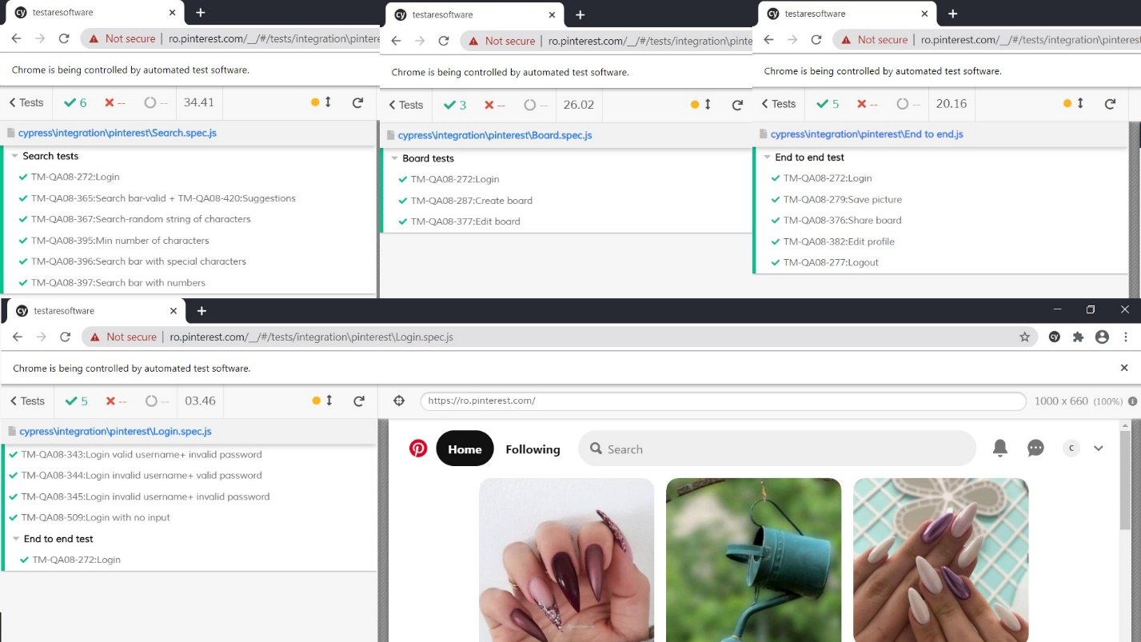

2.4. Lighthouse report

Lighthouse is an open-source, automated tool for improving the performance, quality, and correctness of your web apps.

When auditing a page, Lighthouse runs a barrage of tests against the page, and then generates a report on how well the page did. From here you can use the failing tests as indicators on what you can do to improve your app.

<https://github.com/CarlaHotico/testaresoftware/blob/master/Lighthouse%20report-Pinterest.pdf>

# C. Bugs and improvements

## 3.1. Bugs

| Defect ID | Defect summary | Severity |
| --- | --- | --- |
| 1 | Push notifications not working | Moderate |
| 2 | Search bar allows special characters | Moderate |
| 3 | Internet Explorer – not functional | Moderate |
| 4 | Special character and number allowed for fields such as: First Name, Last Name, Location etc. | Moderate |
| 5 | Account validation email-if button is not clicked, the account does not become inactive | Major |

## 3.2. Improvements

| Defect ID | Defect summary | Severity |
| --- | --- | --- |
| 6 | Faster email notifications | Major |
| 7 | Limited number of characters that are allowed in a field | Moderate |
| 8 | Back-to-top button | Minor |
| 9 | Add Like button for easier pin saving | Moderate |

# D. Conclusions

The testing process was limited due to the lack of requirements, but I was able to test a few key functionalities.

In total I have 49 test cases, all of which have been manually tested. Out of these, I have managed to automate 16, about 30%.

There were 44 manual tests that passed and 4 that failed.

The 16 automated tests all passed.

There are also 14 API tests that passed using the Postman tool.

I have found 5 bugs that have to do with the notifications, validation emails, browser compatibility, text fields for forms that should not allow special characters or numbers, and special character searches. The bug with major severity, the account validation email, should be resolved because it relates to security.

There are 4 improvements:

-notifications by emails that arrive too late;

-text box limits - it is recommended that the number of characters in a text box to be limited to 255 to increase the search processing time;

-a back-to-top button that would make navigating easier for the user;

-a “Like” button that would save your pins quicker.

The test were performed on 2 devices: a laptop with Windows 10 and a Samsung mobile phone with Android. The app was tested on the following browsers on Windows 10: Internet Explorer, Google Chrome, Microsoft Edge. On the mobile phone I tested the mobile application from Google Play as well as the web application on 2 browsers: Internet Samsung and Google Chrome.